Orchestrator

**How to access Orchestrator:**

Login to <http://cloud.uipath.com> and signup with google or outlook. After successful login, the home screen will show you the tenant details with distribution of robots

**Note**: In real project, the IT team will provide the URL to access the orchestrator. Also, refer [Hardware Requirements (uipath.com)](https://docs.uipath.com/installation-and-upgrade/docs/orchestrator-hardware-requirements) for more info.

**How to invite users:**

Manage 🡪 Accounts & Groups 🡪 Invite Users

If a user wants to contribute, then he/she must accept the invite like sending invite for team members to access repo in GIT. Once the user accepts the invite, he/she can access the orchestrator and all robots, machines, queue, assets etc

**To automate the job via Orchestrator first add a machine:**

1. **How to add a Tenant:**

To add a Tenant, navigate to Tenant tab and click Add Tenant and give a name to it.

**Note**: You can see “Add Tenant” button only for the first time and once it is created, you won’t see the button based on the type of Uipath version you are using like Community or Enterprise.

1. **How to add a machine:**

Tenant 🡪 Machines 🡪 Add Machine 🡪 select type of machine as Standard or Template or Elastic

Name 🡪 hostname from cmd or use Ui Path assistant🡪 Profile icon 🡪 Preference 🡪 Orchestrator setting 🡪 Set connection type = machine key and copy the machine name 🡪 Provide all other details for machine and click provision

1. **Orchestrator configuration in UI path assistant:**

Profile Icon 🡪 Preferences 🡪 Orchestrator Setting 🡪 Set connection type = machine key.

Provide Orchestrator URL 🡪 Copy the web address of the orchestrator up to tenant name

Machine key 🡪 Copy the machine key form “Machines” tab from the newly added machine and add the key and then click connect.

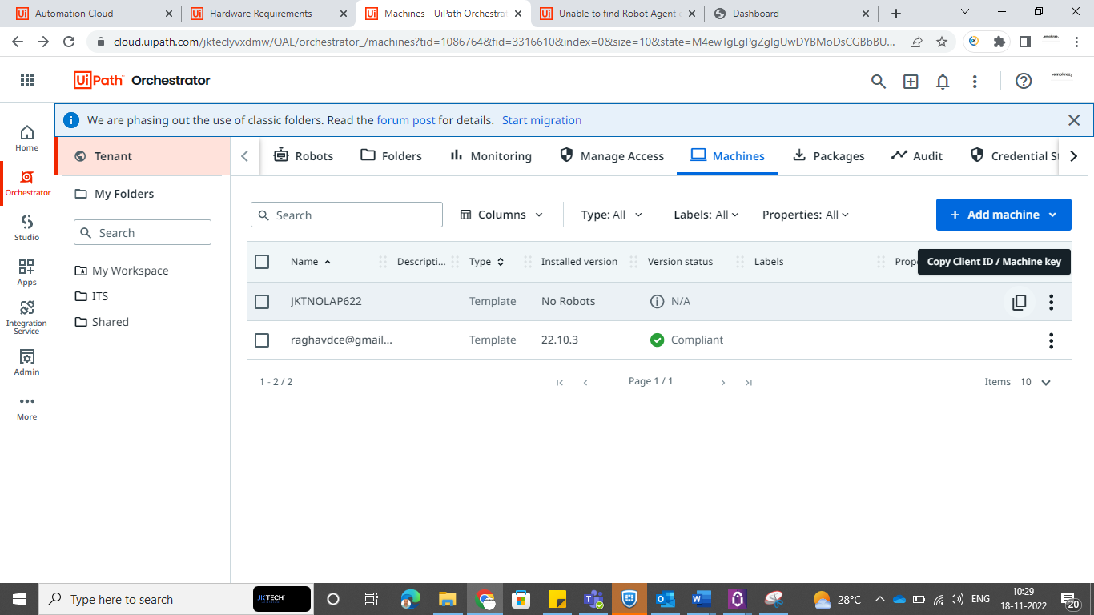

Some time the status will show as Connected, unlicensed. It is because we have added only the machine and not the robot. To cross check it Tenant 🡪 Robots 🡪 it will be empty.

1. **To add a robot:**

Tenant 🡪 Folders 🡪 Click New Folder 🡪 Give a name to it with option as Tenant package fixed 🡪 create

Select the newly created folder and move to “Machine” on the right side 🡪 Manage machines in a folder 🡪 Select the machine and click update

Move to “Users” on the same screen 🡪 you can see username, robot type and roles. To edit it

Accepts the default values for User details, attended robot. In Unattended Robot, turn on the unattended robot and then we need to domain\username (from cmd 🡪 whoami) 🡪 copy the domain\username in the same format 🡪 Provide windows password and don’t change anything in robot settings and click update.

So, if you move to Tenant 🡪 Robots 🡪 You can see the robot details there. Also, the status of the UI path assistant will be connected and licensed now.

1. **How to see the robot status from UiPath Studio:**

To check whether the status of the robot is connected or not. Launch the Ui Path Studio 🡪 More Options 🡪 Connect with Orchestrator 🡪 Provide the Orchestrator URL and Machine key and click connect.

Note: Sometimes it will say access is denied error message and to solve it, go to task manage and end “Uipath user service” task and relaunch ui path studio again and this time you can see the robot status at the bottom

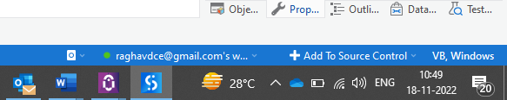

1. **To run jobs via Orchestrator:**

To run a job in orchestrator we should upload package to the orchestrator.

Open a desired project 🡪 Publish on the top right🡪 accept the default by clicking next in all pages 🡪 finally click publish (all are default including certificate i.e., it should be blank).

You will see a successful alert and click ok.

Navigate to Orchestrator 🡪 Click Tenant 🡪 Packages you will see the project

Note: While trying to see the uploaded package, you need to make sure you are in the right path, in my case I have published to my personal workspace

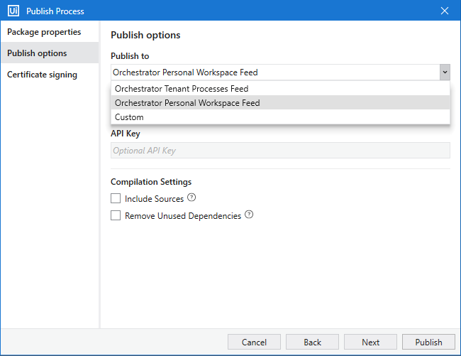

So, the project will be available in the following path

**To create a process:**

Add process 🡪 select the package name which we have uploaded 🡪 accept default and click continue 🡪 provide a process name and click create

Move to Jobs (if the screen displays automatically)

If not, the screen will display like previous to the above one. In either screen, you will have option to “Start job” and click it.

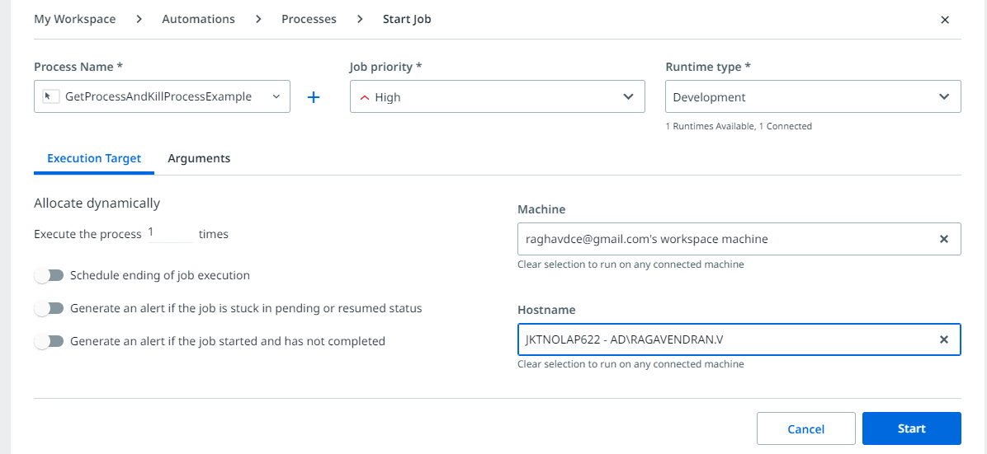

Once user clicks the start, then the rob will start run and it will show the status as below

**How to pass data from Queue:**

1. First create a Queue

Orchestrator 🡪 My Workspace 🡪 Queues 🡪 Add Queue

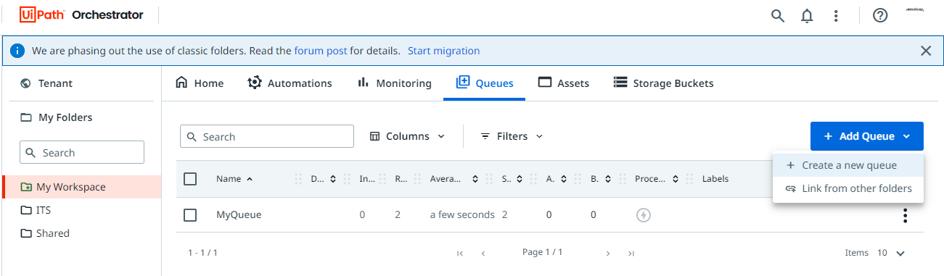

Enter Name 🡪 Action = Archive 🡪 Save

1. Add item to the Queue

Before running “Add Queue Item” activity via UIPath studio with data from excel

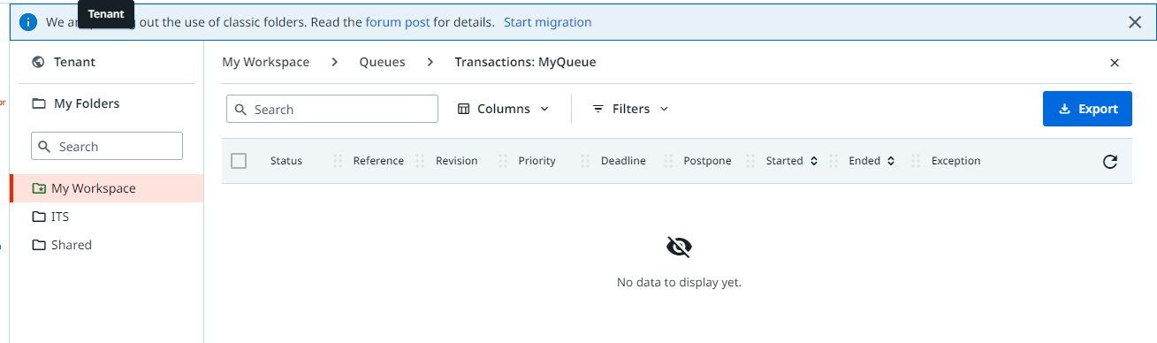

To add items to the queue, first use “Read Range” activity and create a data table for the same. Then use “Add Queue Item” activity inside “For Each” activity to iterate through the data table.

Set “Queue name = queue name created in orchestrator”, add “Item information” as follows

Where key = new variable we need to create and value = reading value from data table

“Reference” is used to execute specific rows **based on condition**. Let us we have four rows and want to execute only 2 rows, then add a column in you excel and have value like ready or ok. Then in reference provide the column header.

**Note**: Condition will be set on “Get Txn Items” activity.

After running Add queue item activity via UI path studio

**Note:** For the first time the status will be new for all the transaction. Once we run “Get Queue Item” activity, it will be modified to “in Progress” and then finally changed to “Successful” (need to set under property of “set queue status” activity).

1. Create one more workflow on the same process
2. First add open browser and indicate the browser we need to automate
3. Use “Get Txn Items” activity and pass the input

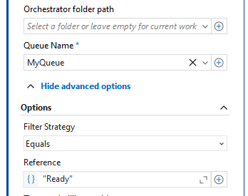

* Queue Name = Queue that we created,
* Filter strategy = Equals
* Reference = Ready (this helps to execute the data whose reference = ready in queue)
* Transaction item = create a new variable (GetQueueItem) with type as “QueueItem”.

1. Add a flow decision with condition = GetQueueItem is Nothing (where “GetQueueItem” is the output variable of Get Txn Item activity)
2. Flow decision is used to avoid exception i.e., when all the data are executed, it will look for anything next in the queue and if it returns empty then it will throw an exception
3. Flow decision = true 🡪 use “Close Application” activity
4. Flow Decision = false (which means it has data) 🡪 add 2 sequence
5. 1st sequence to get all the values from ‘GetQueueItem” using assign activity i.e., create a new variable and assign its value from getQueueItem using “GetQueueItem.SpecificContent("Height(ft)").ToString”

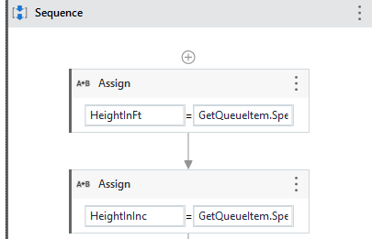

1. In the 2nd sequence, first add “Attach Browser” activity and indicate the application we are going to interact
2. Use “Type Into” activity and pass value to all fields using the variable created in the first sequence
3. Add “Set Txn Status” activity to set the status = Successful and Txn item = GetQueueItem
4. Also, link the 2 sequences to the “Get Transaction Item” activity to make them run in a loop till the last data in the queue